Chapter 11, Sect 1 Highlights (Old Textbook pgs 360-363)
Objectives:
- How is earth’s water distributed among saltwater and freshwater sources?
- How does Earth’s water move through the water cycle?
Water on Earth
- What % of planet Earth is water?

- Where is most of this water located?

Use the figure below to answer question 3 through 5. Write the letter of the correct answer in the space provided.
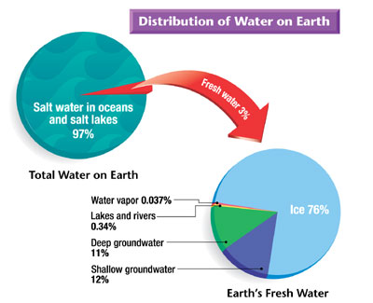

- What percent of Earth’s water is salt?

- What percent of Earth’s water is fresh?

- What state of matter is most of the fresh water on Earth?

- List the state of matter that water is in the following examples:

Water vapor –

Shallow groundwater –

Glacier –

- What is the source of energy for the water cycle?

Use the figure below to answer question 1 through 5. Write the letter of the correct answer in the space provided.
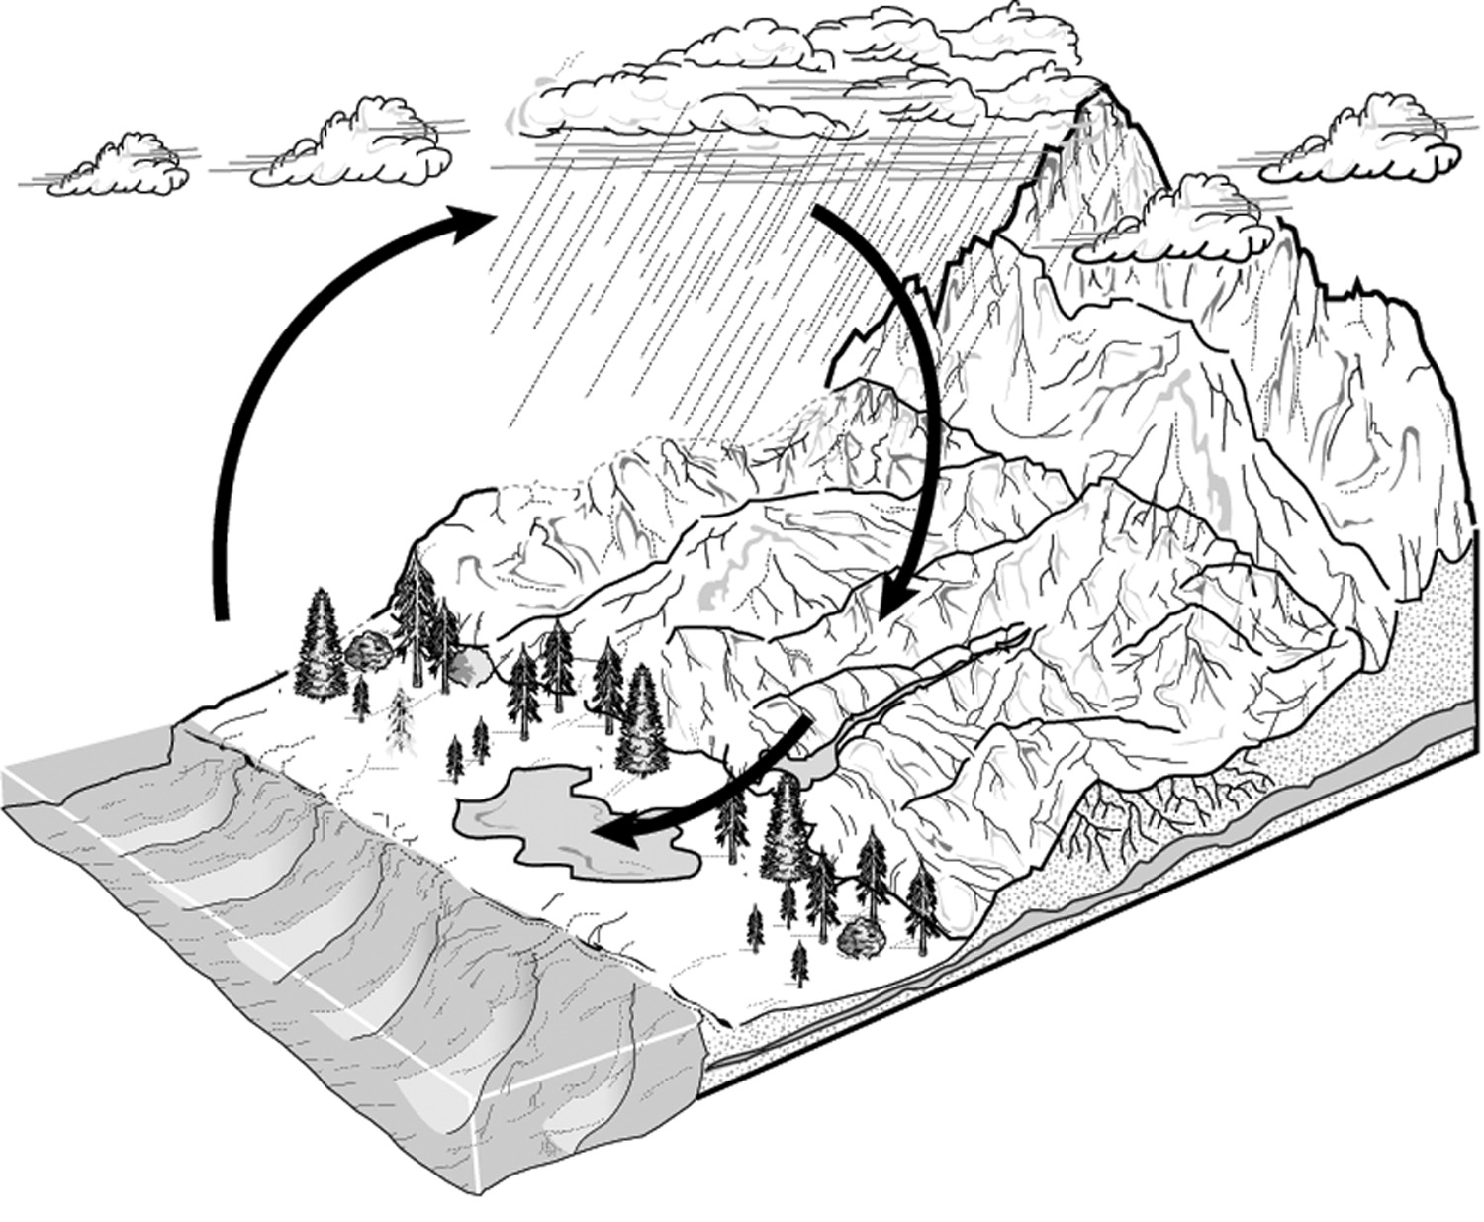
D
C
A
E
B
8. Which letter indicates evaporation?
9. Which letter indicates transpiration?
10. Which letter indicates precipitation?
11. Which letter indicates runoff?
12. Which letter indicates condensation?

TRUE OR FALSE
If the statement is true, write true. If it is false, change the underlined word to make the statement true.
13. Most of Earth’s liquid fresh water is found in the form of lakes? ____________________
14. In the water cycle, precipitation returns salt water to Earth. _______________________
15. The process by which the leaves of plants give off water into the atmosphere is condensation. _______________________________________________________________
16. Water vapor gains energy during the process of condensation. ____________________

