**Chapter 11, Sect 3 Highlights (Old Textbook pgs 378-381)**

**Objectives:**

1. How does water move through underground layers of soil and rock?
2. Describe an aquifer?

**Underground Layers (pgs. 378-379)**

1. Precipitation that soaks into the ground trickles downward due to ______________.

Match the term with its definition.

Term Definition

____ 2. pore a. Allows water to pass through

____ 3. permeable b. Area that is totally filled with water

____ 4. impermeable c. Space between rock and soil particles

____ 5. saturated zone d. Does not let water pass through

____ 6. water table e. Layer above the water table

____ 7. unsaturated zone f. Top of the saturated zone

1. In the drawing, label the water table, saturated zone, and unsaturated zone. Color the saturated zone blue and the unsaturated zone brown.

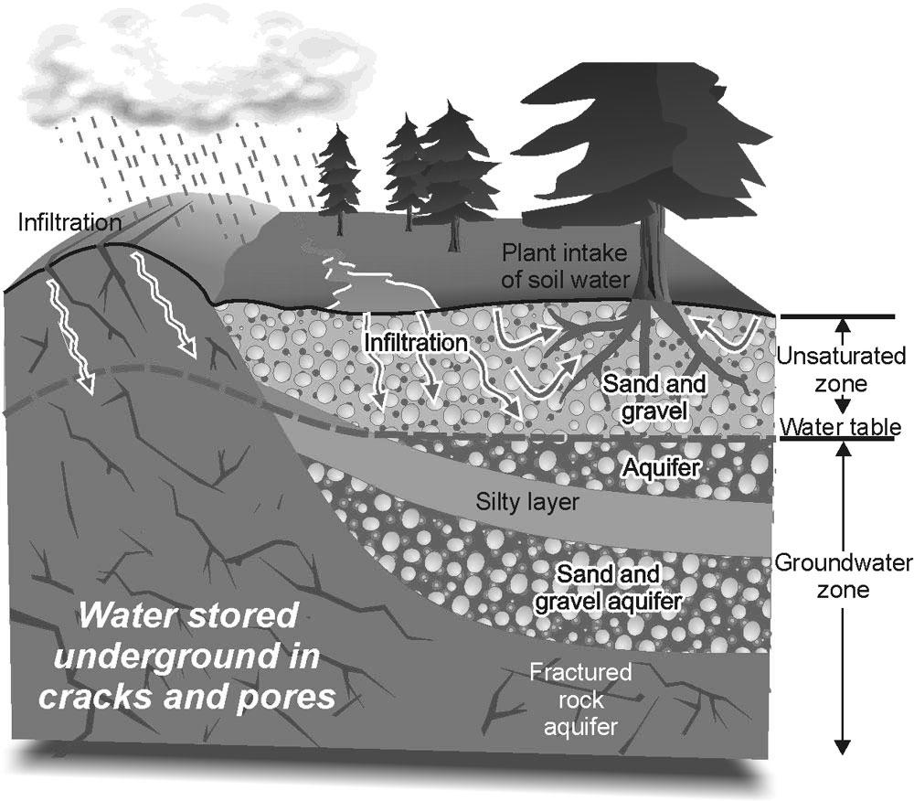

_____________________

_____________________

_____________________

**AQUIFERS (pg. 380)**

1. Any underground layer of rock or sediment that holds water is called a(n) ________________.
2. Circle the letter of each sentence that is true about aquifers.
3. All of them are very large.
4. They can provide drinking water.
5. They can provide water for crops.
6. They contain moving water.

**BRINGING GROUNDWATER TO THE SURFACE (pgs. 380-381)**

1. Is the following sentence true or false? The depth of the water table is always the same, even over a large area of land. _____________________________________.
2. What raises the level of the water table, and when does the level fall? ______________________________________________________________________________________________________________________________________________________________________________________________________________.
3. Where the water table meets the ground surface, groundwater bubbles or flows out of cracks in the rock in places called _______________________.
4. Circle the letter of the choice that best explains how to get water from an aquifer with a well.
5. By drilling below the water table
6. By drilling below the aquifer
7. By drilling through the impermeable rock
8. By drilling near a dry well
9. Is the following sentence true or false? Pumping water out of an aquifer in a well raises the water level near the well. ______________________________________.
10. New water that enters an aquifer from the surface is called ___________________.
11. A well in which water rises because of pressure within an aquifer is called a(n) _______________________________________. (Also known as an artesian **spring**).
12. Look in your new text on pg. 320 and provide synonyms for the following two words:

Saturated layer –

Unsaturated layer –