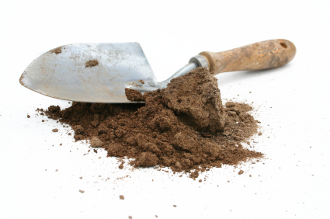
"Dirty" Words

In order to demonstrate your understanding/knowledge of the scientific vocabulary related to Chapter 10 (Weathering and Soil Formation), Chap 11 (The Flow of Fresh Water), Chap 12 (Agents of Erosion and Deposition), and Chap 5 (Energy Resources) you will prepare a brief presentation. This presentation will count as a TEST GRADE.

You must follow the guidelines below:

- You will select a word from the vocabulary strips that your teacher has prepared.

MY WORD IS ______________________________________________________

- You will prepare a two to three (3-4) minute speech, teaching this word to the entire class. Use your RESOURCES (textbook would be the first place to start, MOM, Cobb Digital Library, and internet (with parent permission and supervision)) or any other reliable resource. Follow the Hints for Oral Presentations guidelines reviewed/highlighted in class.

- You will develop a visual aid or model that will accompany your speech.

DATE PRESENTATIONS BEGIN_____________________________________

No power point presentations without prior approval from your teacher please

REMEMBER:
Your grade depends upon the quality of your work and presentation. Frequently refer to the directions AND the rubric, on the back of this page, to achieve the highest grade possible.
 | 2 | 3 | 4 | 5
Organization | Presentation does not follow any guidelines from Hints for Oral Presentations. | Missing 2 (TWO)…intro, body, OR conclusion, and used suggestions from Hints... | Missing 1 (ONE)…intro, body, OR conclusion, and used suggestions from Hints... | Contains introduction, body, conclusion, and several suggestions from Hints for Oral Presentations.
Content Knowledge | Student does not display an understanding of the information presented. Presentation lasted under 3 minutes. | Student demonstrates basic knowledge – is uncomfortable with the topic. Presentation lasted under 3 minutes or over 4 minutes. | Student demonstrates slightly more than basic knowledge. Was thorough but did not go the extra mile (lacked) abundant knowledge. | Student demonstrates (more than required) abundant knowledge with explanations and details. Presentation lasted between 3 to 4 minutes.
Visual | Visual was related to the presentation BUT was very poor quality. | Visual reinforced the presentation and was of very good quality. | Visual reinforced the presentation and was of very high quality. | Visual reinforced the presentation, went “above and beyond,” and was of the highest quality.
Delivery | Student mumbles, incorrectly pronounces terms, speaks too quietly, and entire report is read from notes OR is unprepared to present. | Student’s voice is, at times, unclear, many mispronounced terms, and student reads mostly from notes. | Student’s used a clear voice, correct pronunciation of terms, made some direct eye contact, and occasionally refers to notes. | Student used a clear voice, correct pronunciation of terms, made constant direct eye contact with audience, and seldom looked at notes.
Audience Response | Did not hold the audience’s attention for the entire presentation and/or audience lost interest. | Held the audience’s attention some of the presentation. Some portions the audience was bored. | Held the audience’s attention the entire time. Interesting presentation, but lacked enthusiasm. | Held the audience’s attention the entire time, and kept and captured their attention. Had pizzaz/maybe some sort of “hook!”

__________ x 4 = _____________ (Final Grade)

